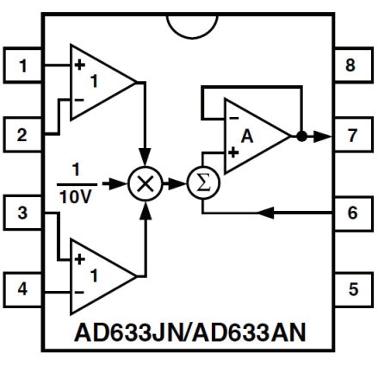
+15 V
-15 V
s_{i}(t)
s_{p}(t)
s(t)

